IDEAL_IGBT library and symbols for Ltspice 4 and 17

# Files

* IDEAL_B6CI.asy
* IDEAL_IGBT.asy
* IDEAL_IGBT.lib
* IDEAL_IGBT_Halfbridge.asy
* Example Circuits
  + Inverter using B6CI block.asc
  + Inverter using HalfBridge blocks.asc
* Symbol Schematics
  + IDEAL_B6CI.asc
  + IDEAL_IGBT.asc
  + IDEAL_IGBT_Halfbridge.asc

# Installation

Copy the library files to the locations specified below. Restart Ltspice.

**Ltspice 4:**

* Copy *.lib to C:\Program Files (x86)\LTC\LTspiceIV\lib\sub
* Copy *.asy to C:\Program Files (x86)\LTC\LTspiceIV\lib\sym

**Ltspice 17:**

* Copy *.lib to %HOMEPATH%\Documents\LTspiceXVII\lib\sub
* Copy *.asy to %HOMEPATH%\Documents\LTspiceXVII\lib\sym

%HOMEPATH% is usually “C:\Users\<username>\” so the Ltspice files will be copied to a subfolder within the user’s own “My Documents” folder. Some Ltspice installations may differ.

# Use

From the schematic sheet in Ltspice press F2 to add a new component. The IDEAL components should be listed in the “Select Component Symbol” box. Build the circuit using the selected component.

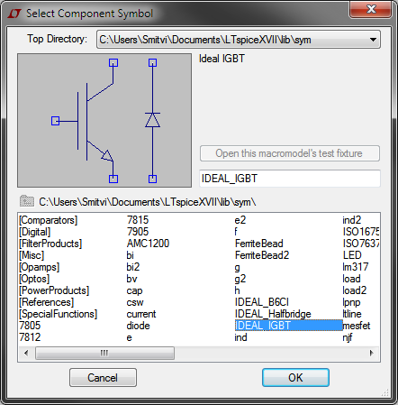

# Symbol Description

## IDEAL_IGBT

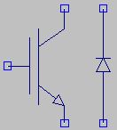

The IGBT is turned on when 1V is applied to the gate terminal, referenced to the global GROUND net (usually “0”). There is no need to create floating supplies for IGBTs whose emitters are connected to non-ground potentials.

Separate connections must be made to the IGBT and anti-parallel diode. They would normally be connected in parallel. The symbol was designed this way to allow for the user to probe IGBT and diode currents separately.

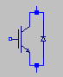

## IDEAL_Halfbridge

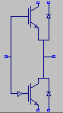

When a 1V signal is applied to the gate input the top IGBT is turned on and the bottom IGBT is turned off. When a 0V signal is applied, the top IGBT is turned off and the bottom IGBT is turned on.

Like the IDEAL_IGBT symbol, separate connections must be made to the IGBT and diodes.

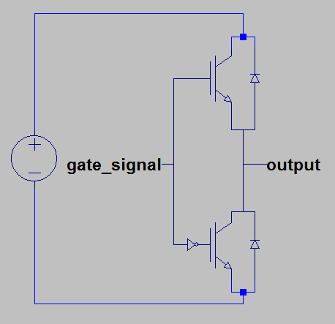

## IDEAL_B6CI

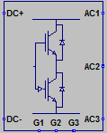

The IDEAL_B6CI is the combination of three halfbridges in a single, easy to connect symbol. All internal connections to IGBTs and diodes are brought out to a DC+ and a DC- pin. The symbol does not provide easy access to the individual IGBT and diode currents.

Gate signals are applied to the Gx inputs. Corresponding halfbridge outputs appear on the ACx pins.